Purpose of Spreadsheet

The purpose of the spreadsheet is to allow the specialist to record the support they give electronically. The spreadsheet would be able to calculate many more features than their current paper based system.

User Guide

Homepage:- This is the first sheet that display the macros that will take the user to the different sheets. The screenshot below show the different macro buttons.

A macro button to take the user to the 'Specialist Overall' Sheet

A macro button to take the user to the 'Course Overall' Sheet

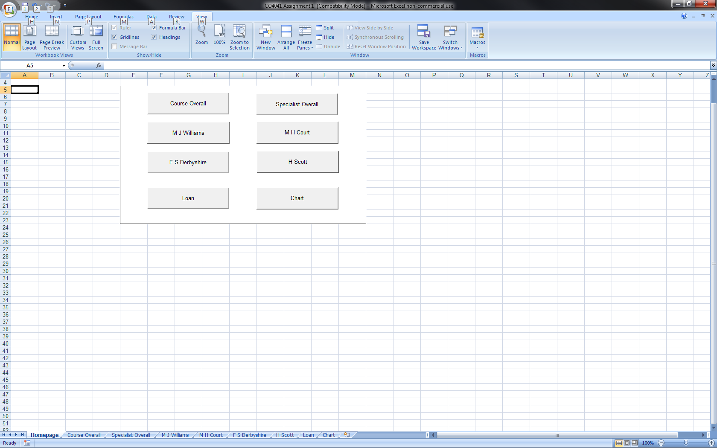

A macro button to take the user to the specialist 'M J Williams' Sheet

A macro button to take the user to the specialist 'F S Derbyshire' Sheet

A macro button to take the user to the specialist 'M H Court' Sheet

A macro button to take the user to the

specialist 'H Scott' Sheet

A macro button to take the user to the 'Chart' Sheet

A macro button to take the user to the 'Loan' Sheet

Course Overall:- This is the course overall which displays the overall course information gather from all the specialists sheets. The screenshot below shows the different features on the sheet.

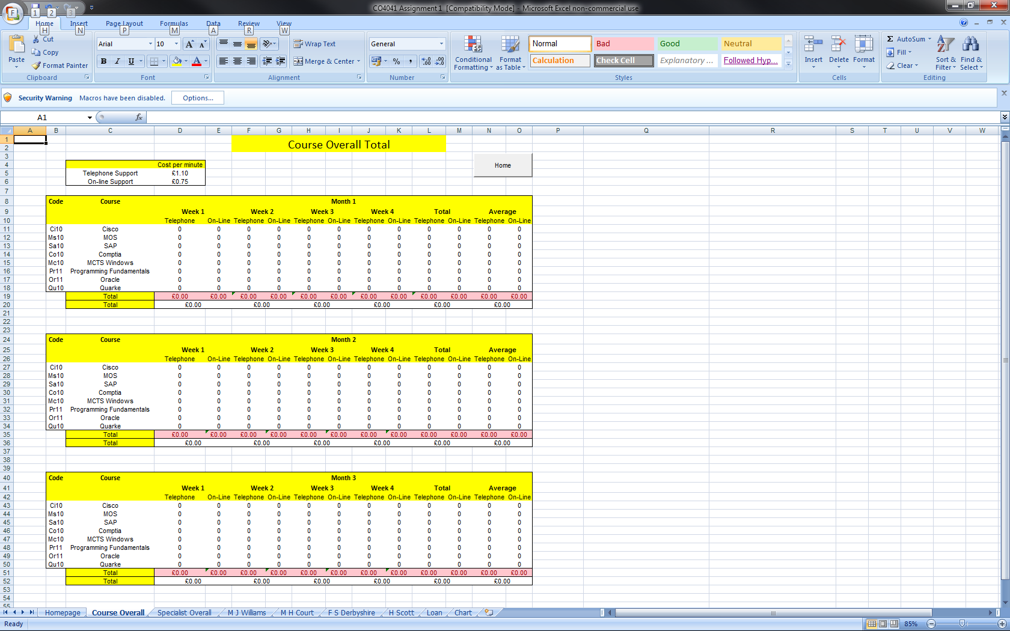

The total support of each specialist

The average support of each specialist

Overall total of the weeks support income

Conditional formatting on the individual support that shows red if they are generating less than £1000

One week of the support from the course

One month of the support from the course

A macro button to take the user back to the 'Homepage' Sheet

The costs of the support

The screenshot below shows the same sheet but will test data from the other sheets. The different conditionings and formulas are working correctly.

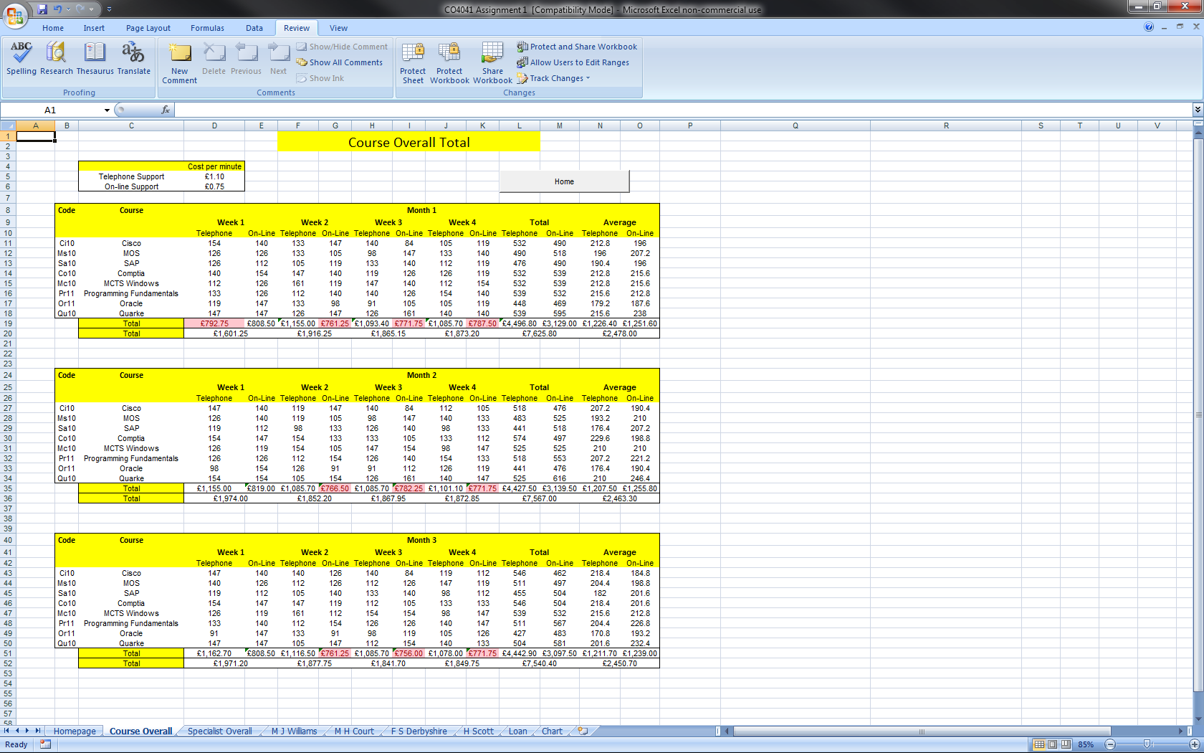

The next few pages show the screenshot of the spreadsheets formula.

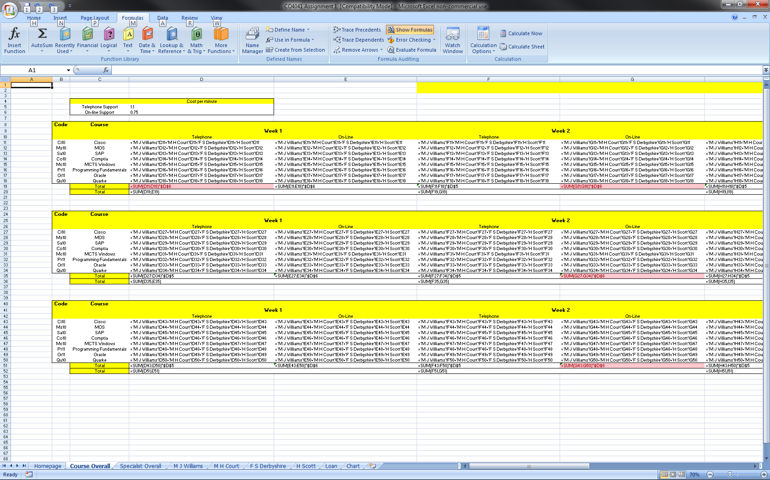

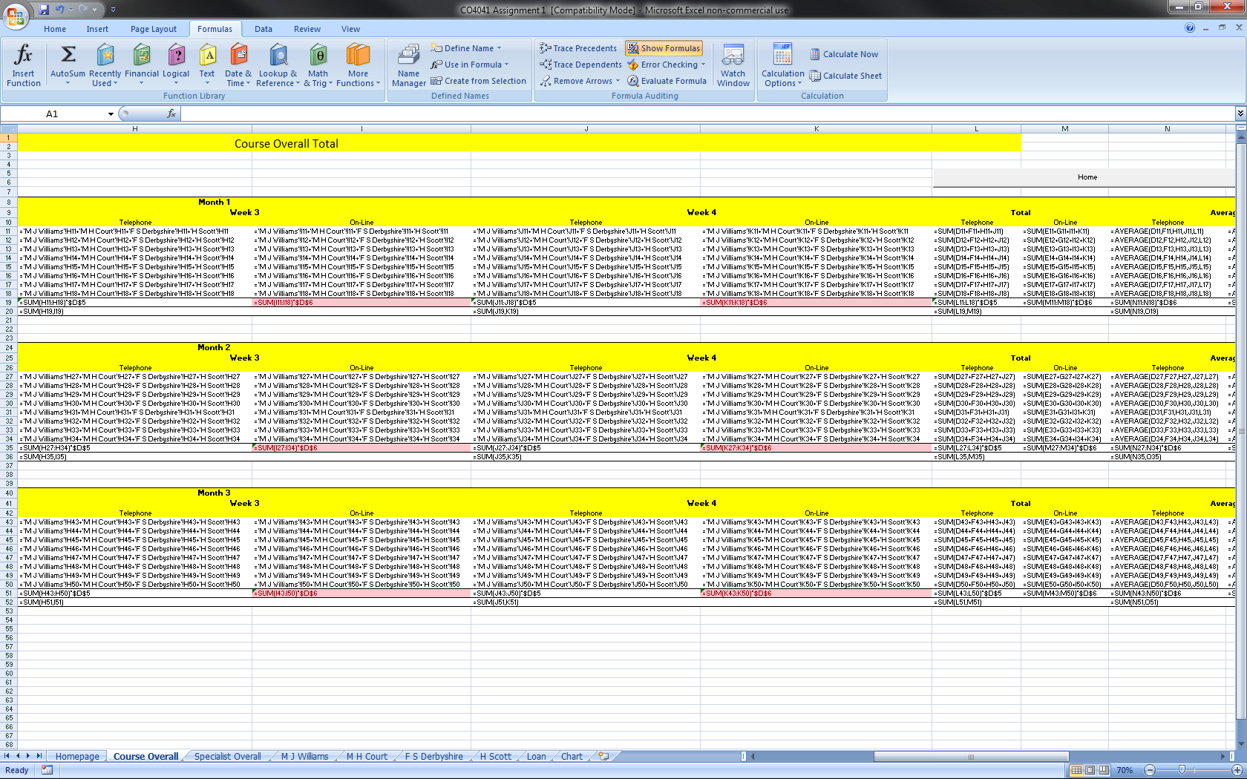

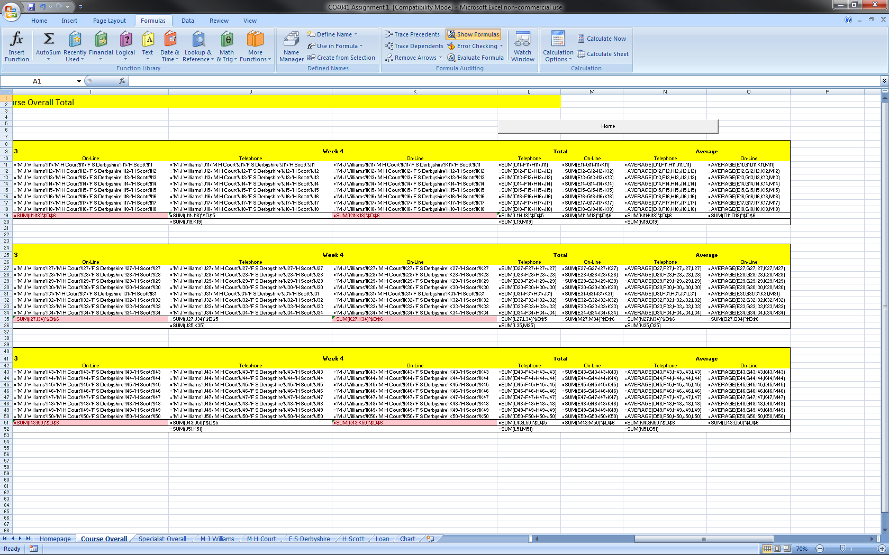

Specialist Overall:- This is the specialist overall which displays the overall specialist information gather from all the specialists sheets. The screenshot below shows the different features on the sheet.

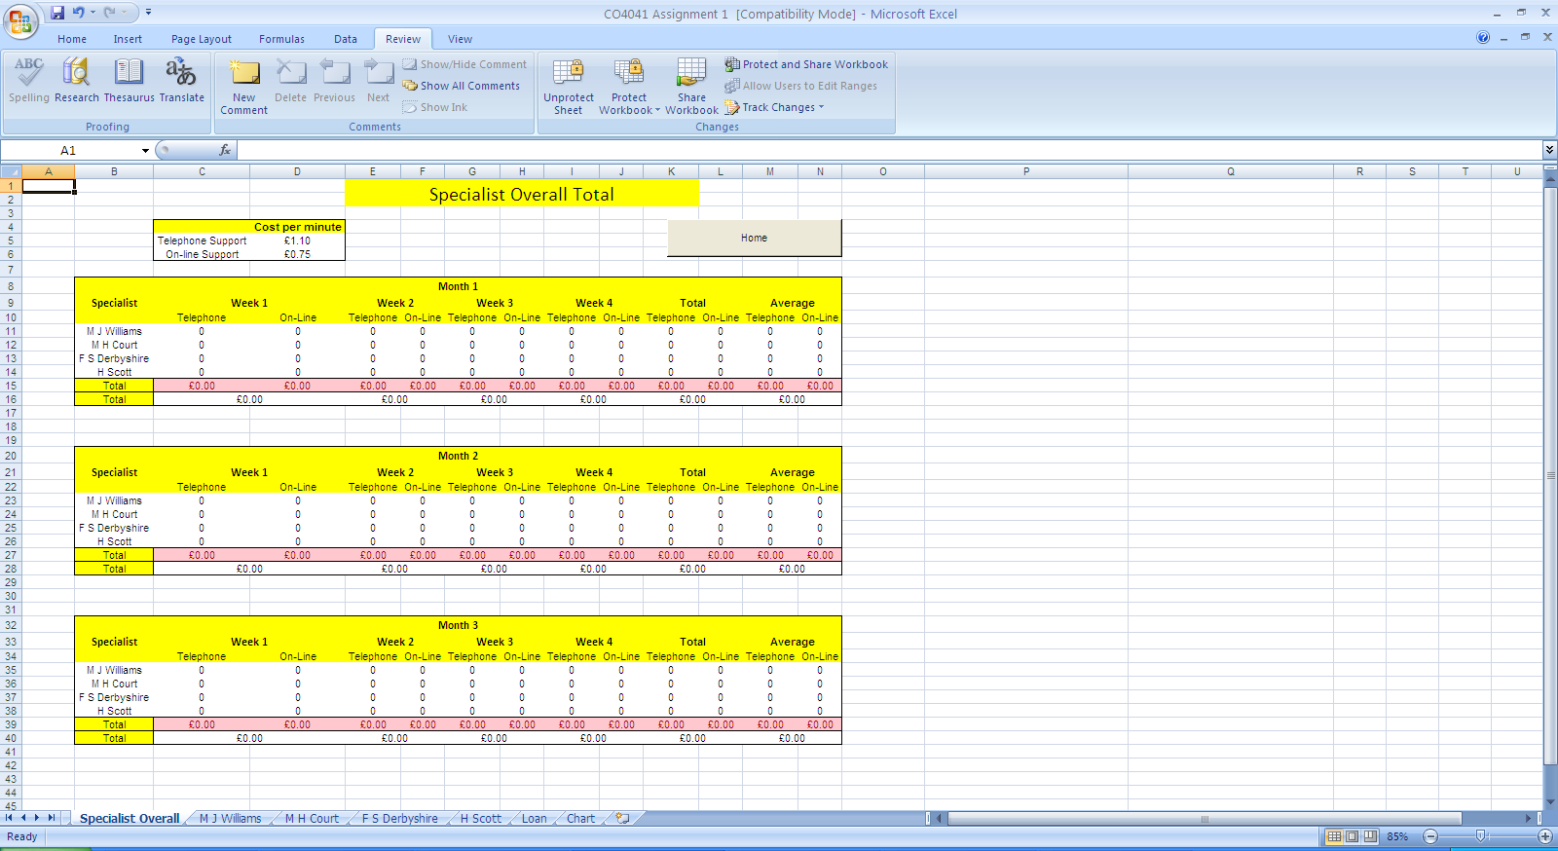

The costs of the support

A macro button to take the user back to the 'Homepage' Sheet

Conditional formatting on the individual support that shows red if they are generating less than £1000

One month of the support from the specialists

One week of the support from the specialists

The total support of each specialist

The average support of each specialist

Overall total of the weeks support income

The screenshot below shows the same sheet but will test data from the other sheets. The different conditionings and formulas are working correctly.

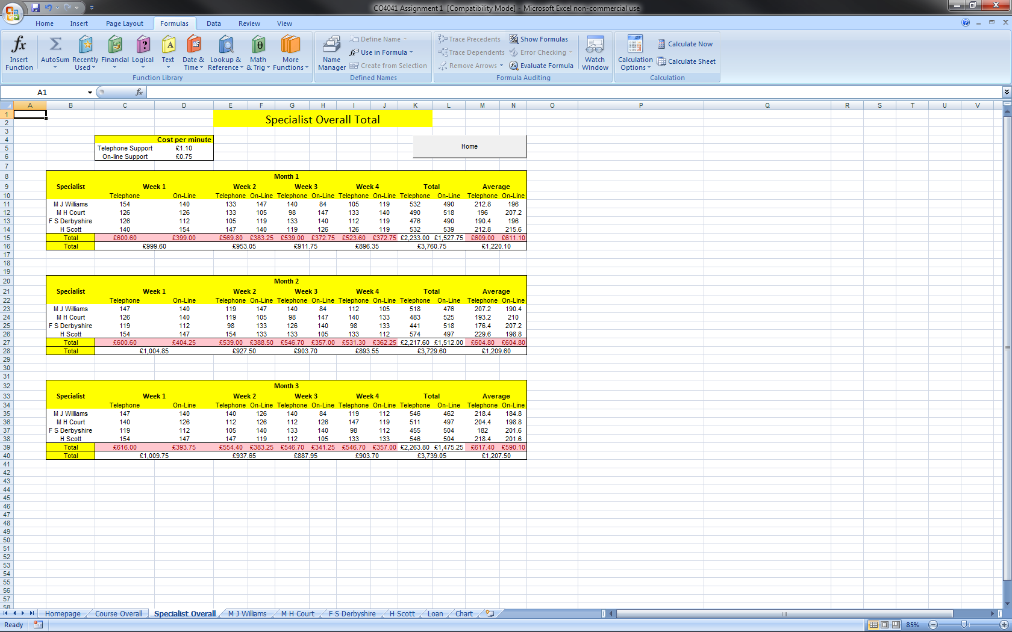

The next few pages show the screenshot of the spreadsheet's formula.

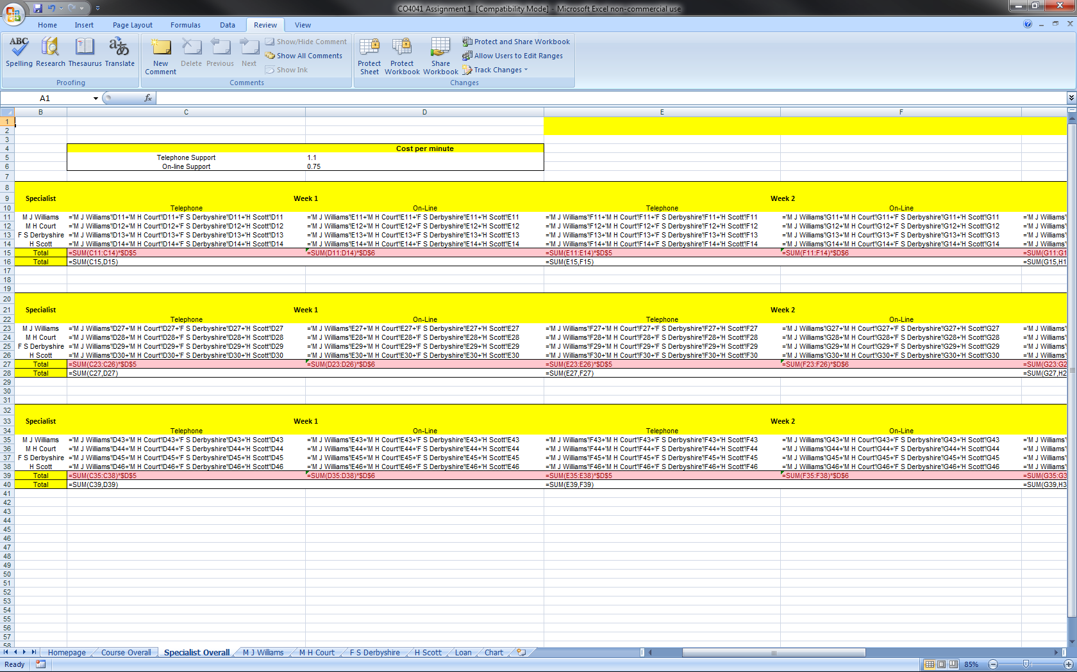

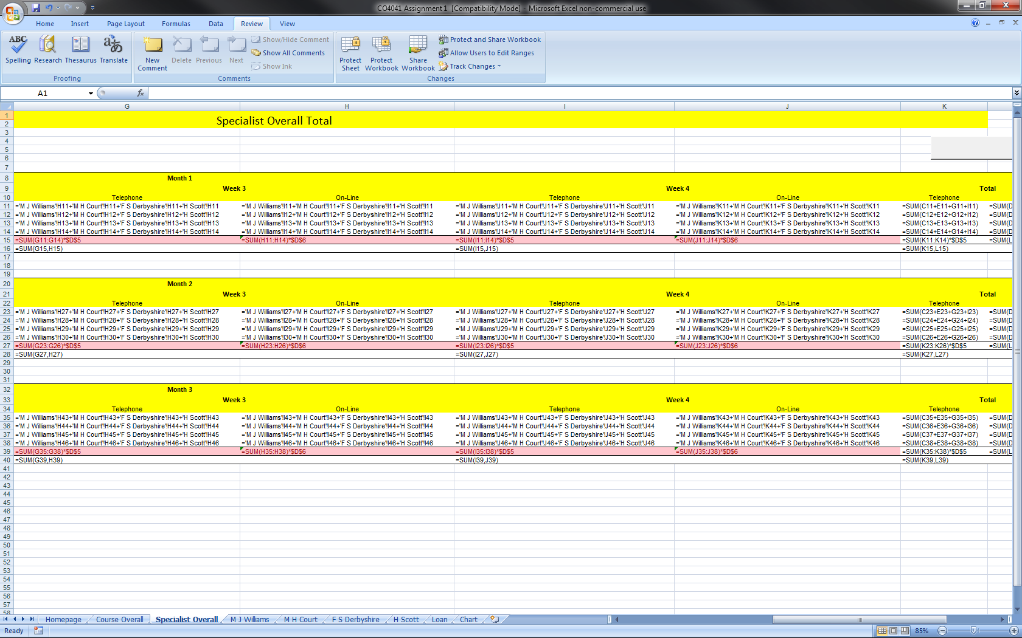

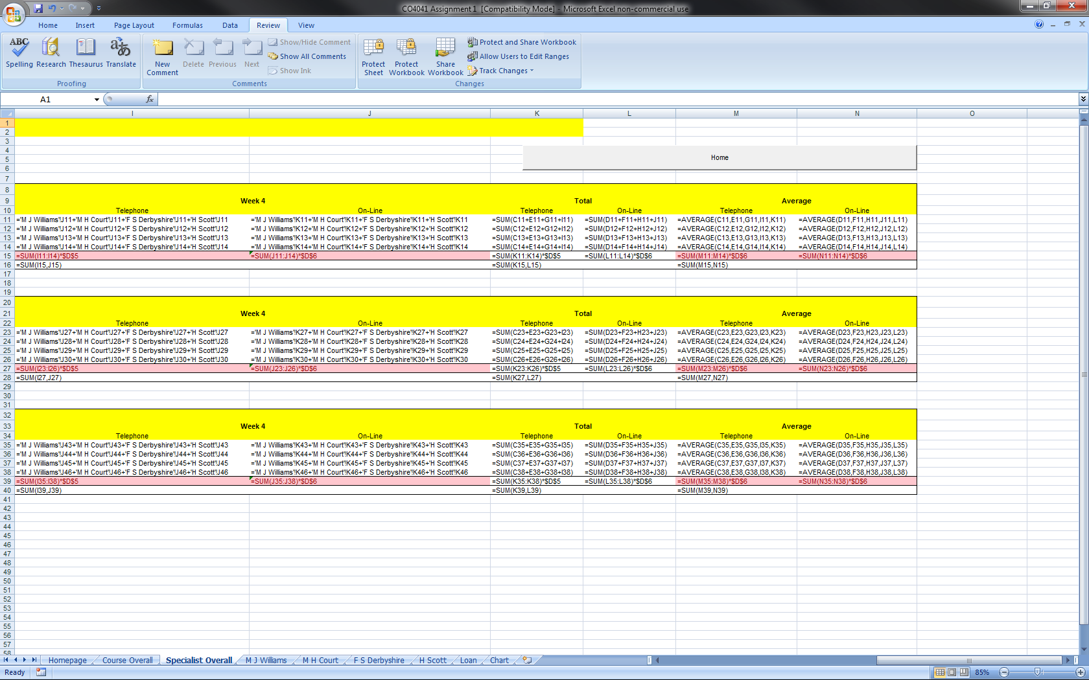

M J Williams:- This is the specialist sheet 'M J Williams' which displays the specific specialist information. The screenshot below shows the different features on the sheet.

The costs of the support

A macro button to take the user back to the 'Homepage' Sheet

Conditional formatting on the individual support that shows red if they are generating less than £1000

One month of the support from the course

One week of the support from the specialists

The total support of each specialist

The average support of each specialist

Overall total of the weeks support income

The bonus requirement for the specialist

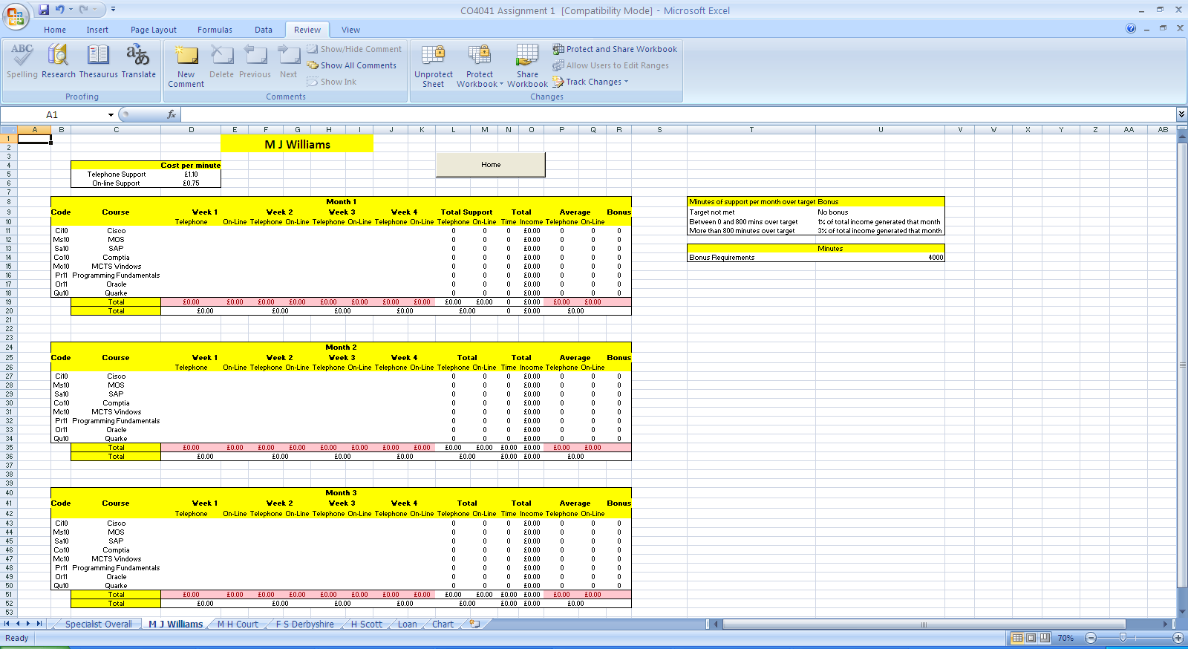

The screenshot below shows the same sheet but will test data. The different conditionings and formulas are working correctly.

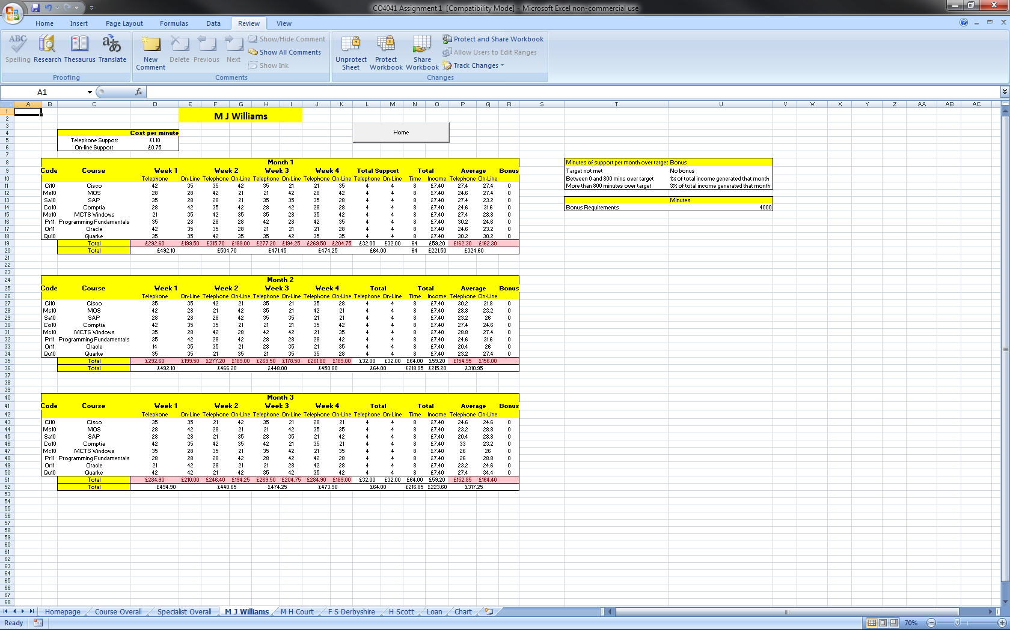

The next page shows the screenshot of the spreadsheet's formula.

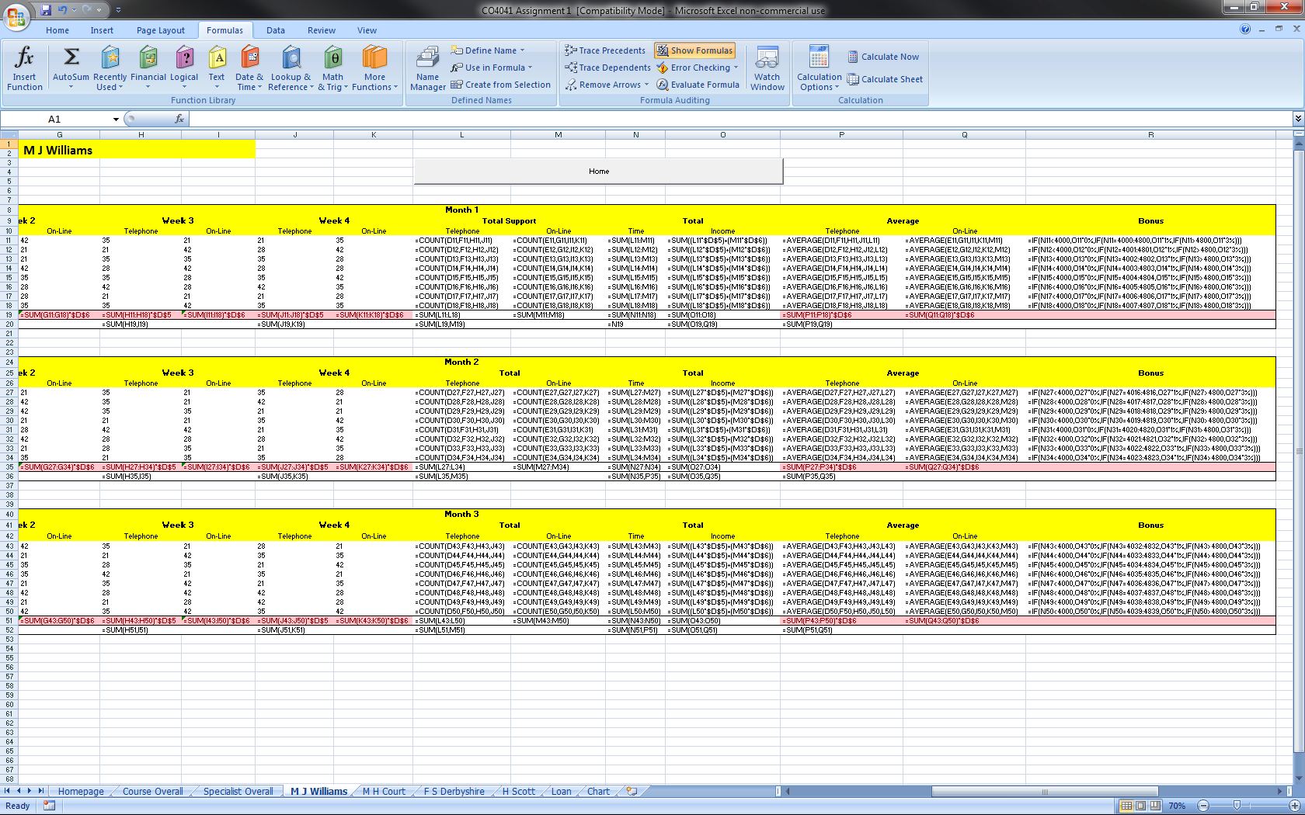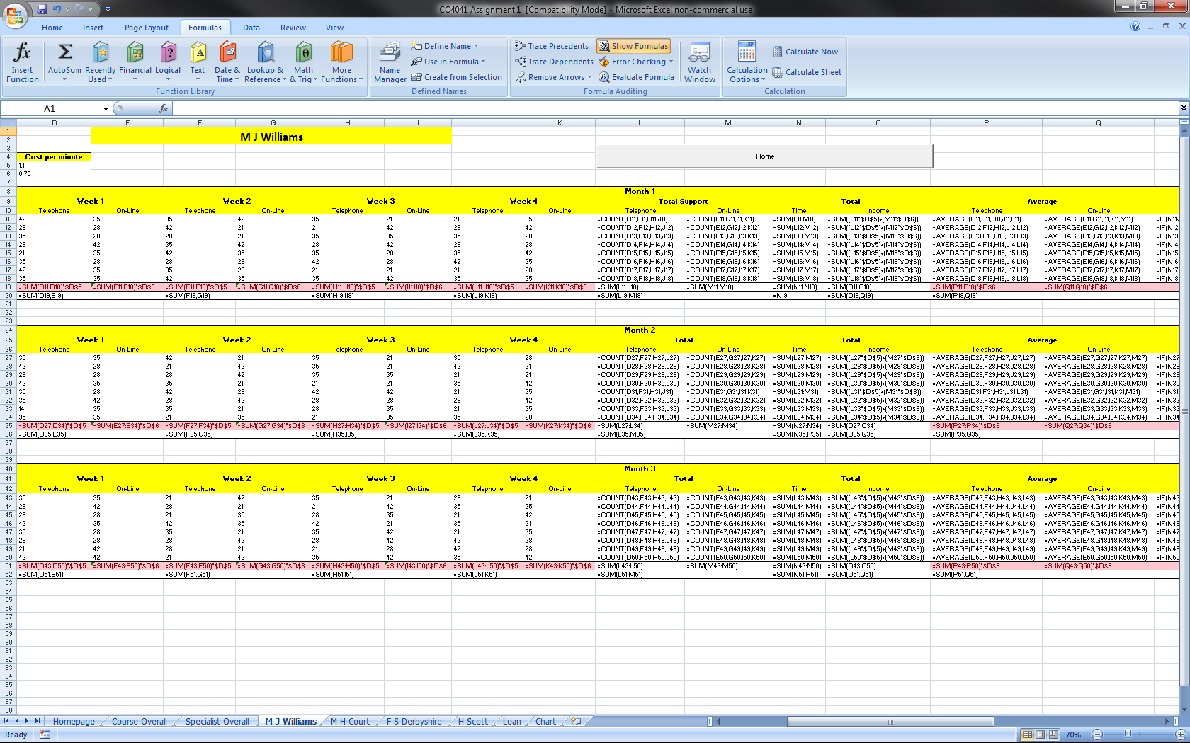

F S Derbyshire:- This is the specialist sheet 'F S Derbyshire' which displays the specific specialist information. The screenshot below shows the different features on the sheet.

The costs of the support

A macro button to take the user back to the 'Homepage' Sheet

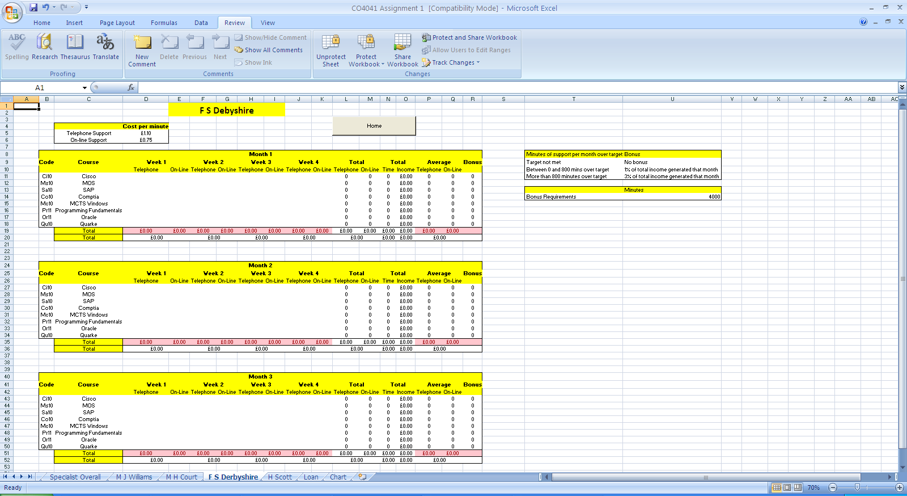

One month of the support from the course

Conditional formatting on the individual support that shows red if they are generating less than £1000

The average support of each specialist

The total support of each specialist

Overall total of the weeks support income

One week of the support from the specialists

The bonus requirement for the specialist

The screenshot below shows the same sheet but will test data. The different conditionings and formulas are working correctly.

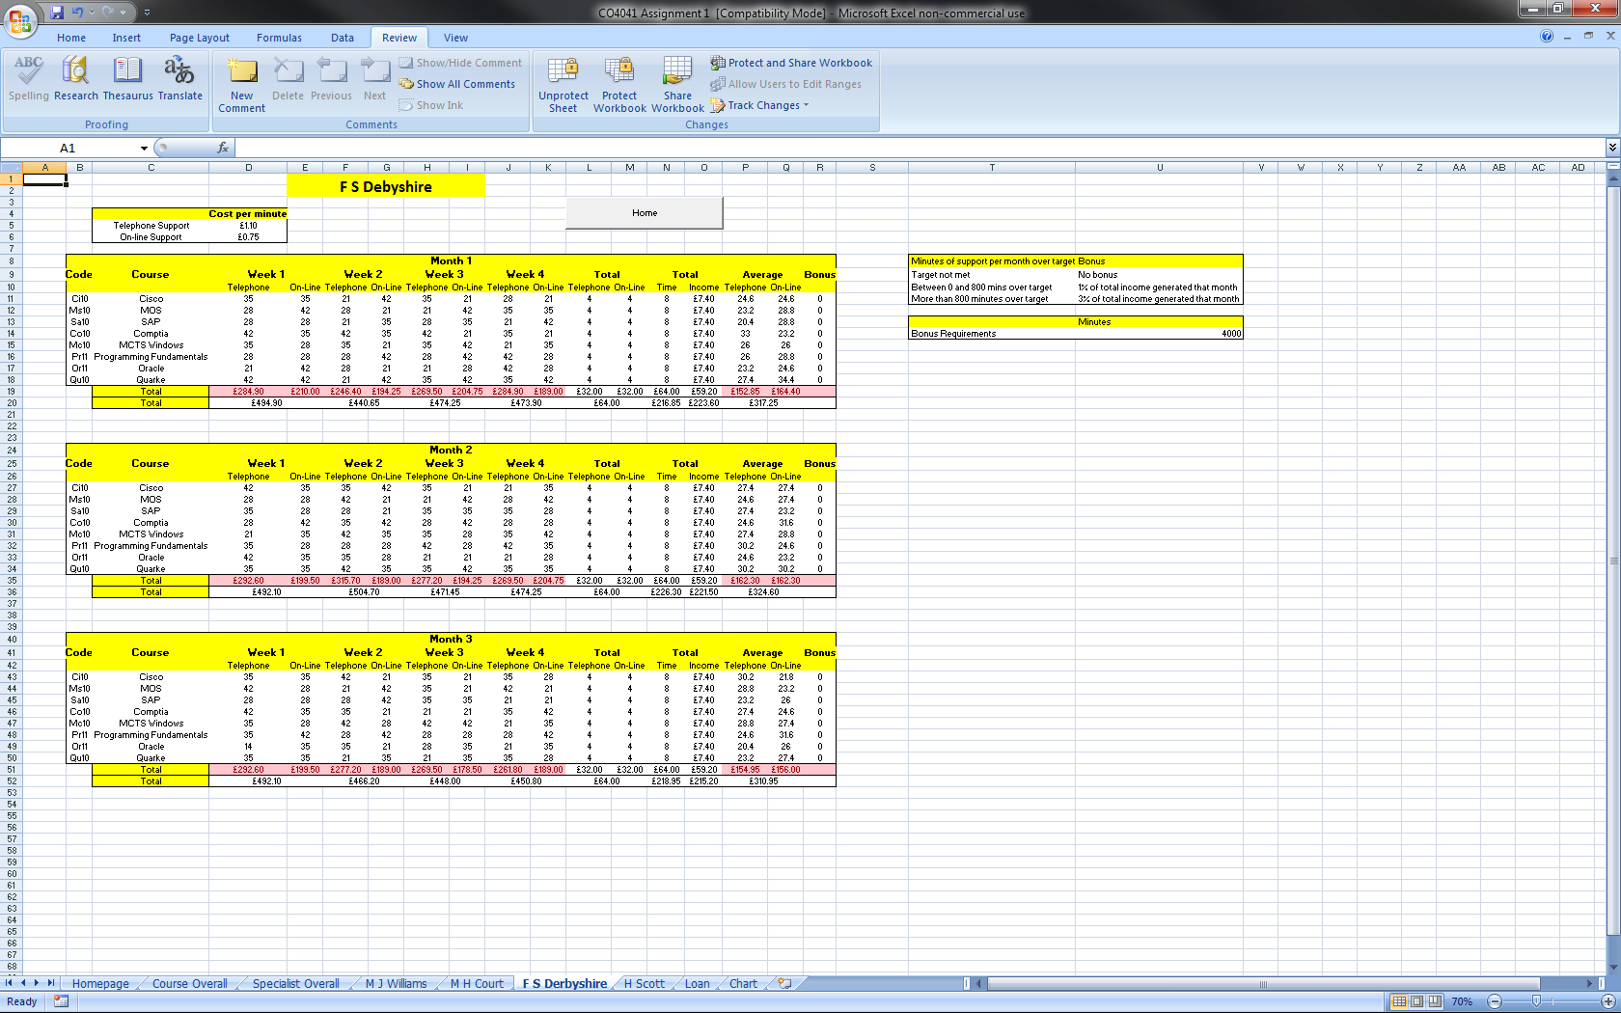

The next page shows the screenshot of the spreadsheet's formula.

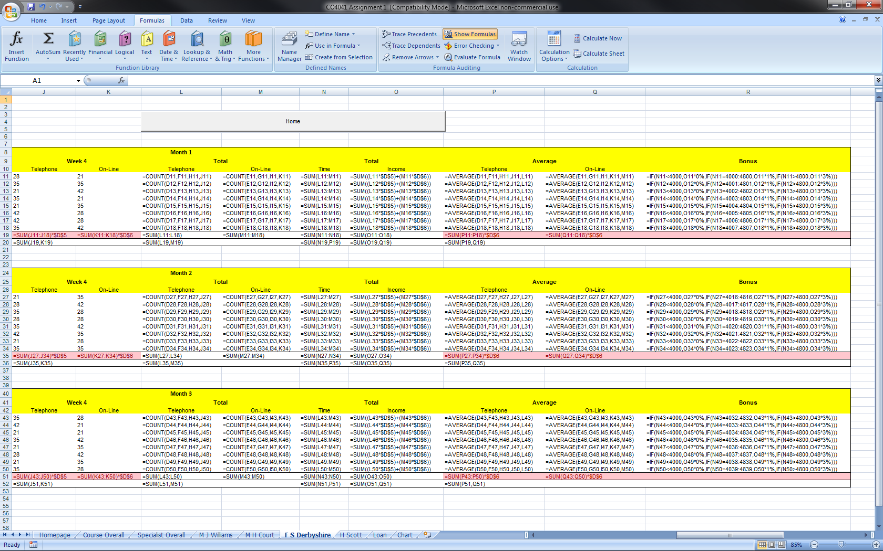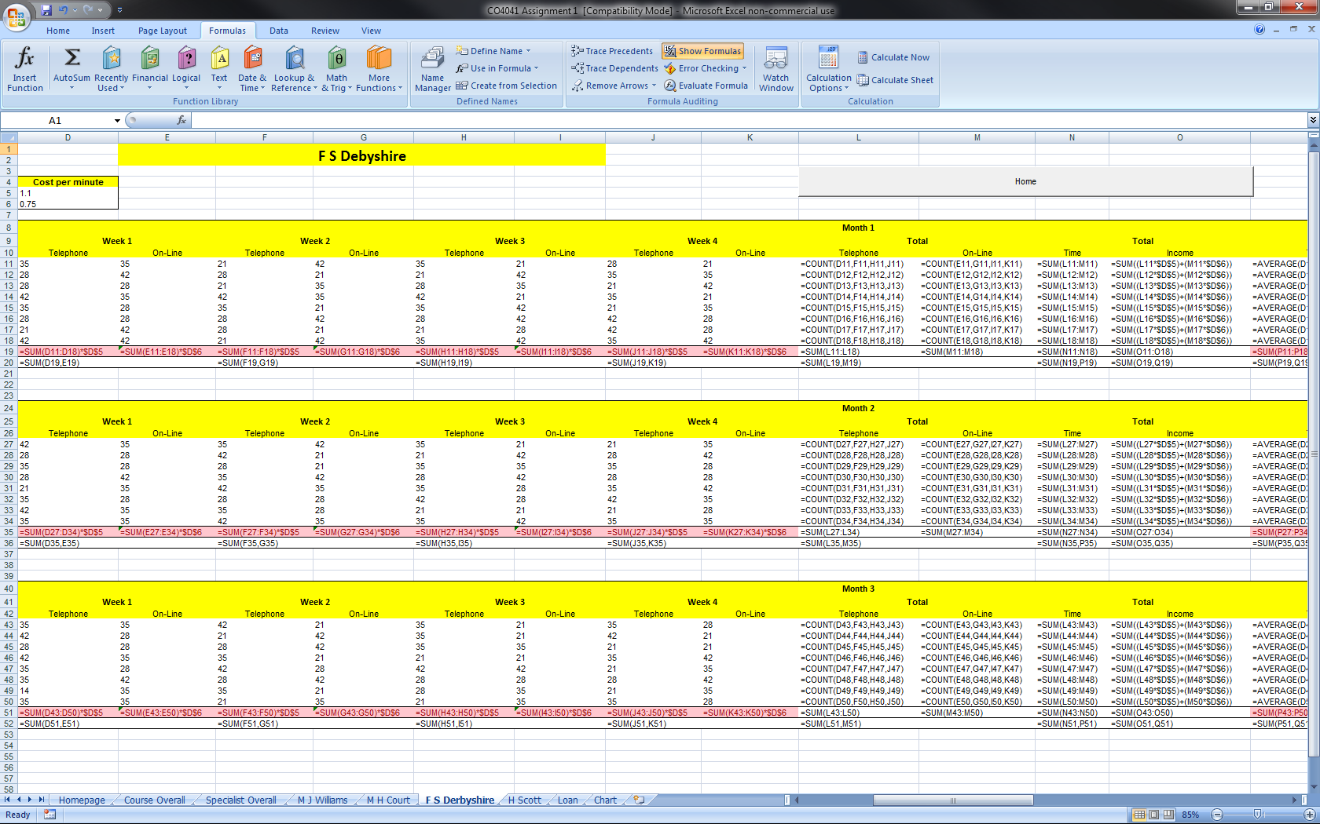

M H Court:- This is the specialist sheet 'M H Court' which displays the specific specialist information. The screenshot below shows the different features on the sheet.

The costs of the support

A macro button to take the user back to the 'Homepage' Sheet

Conditional formatting on the individual support that shows red if they are generating less than £1000

One month of the support from the course

One week of the support from the specialists

The total support of each specialist

The average support of each specialist

Overall total of the weeks support income

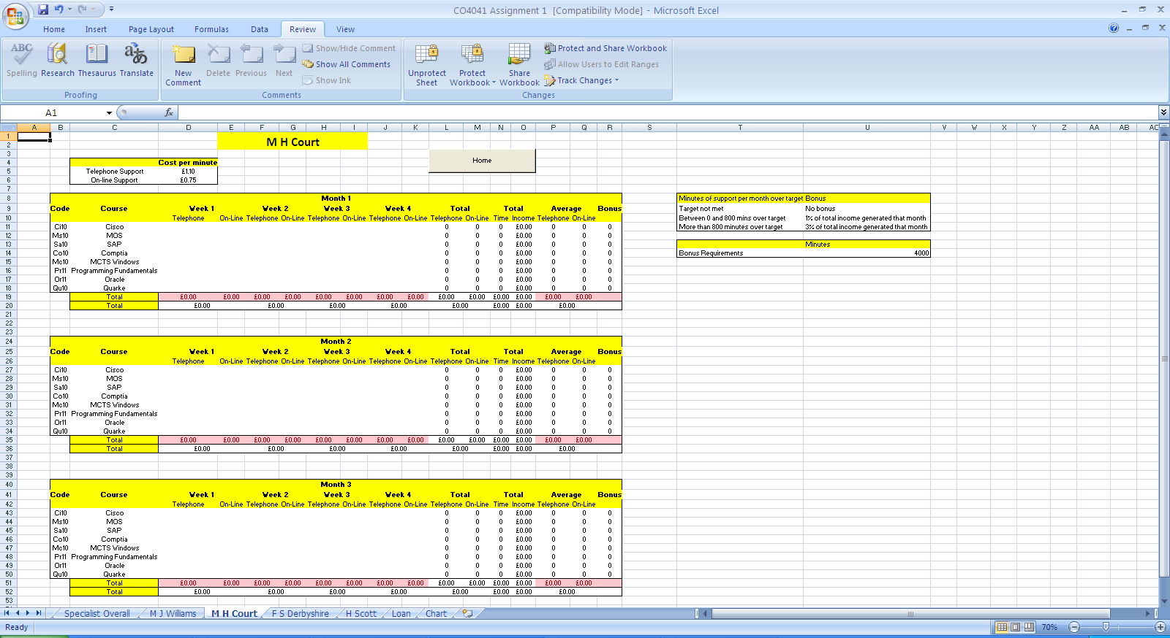

The bonus requirement for the specialist

The screenshot below shows the same sheet but will test data. The different conditionings and formulas are working correctly.

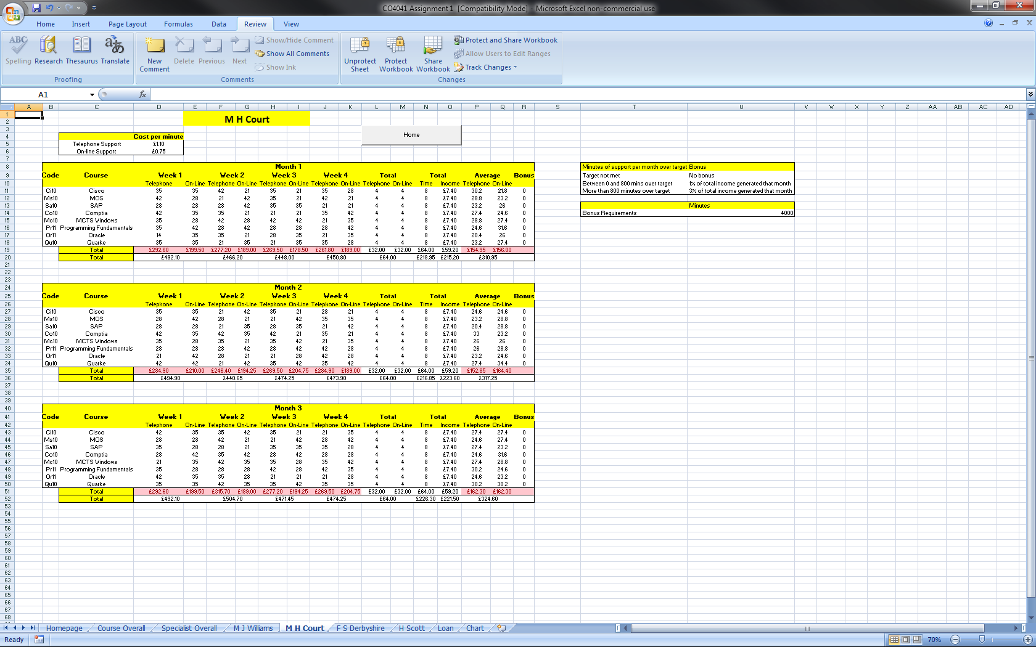

The next page shows the screenshot of the spreadsheet's formula.

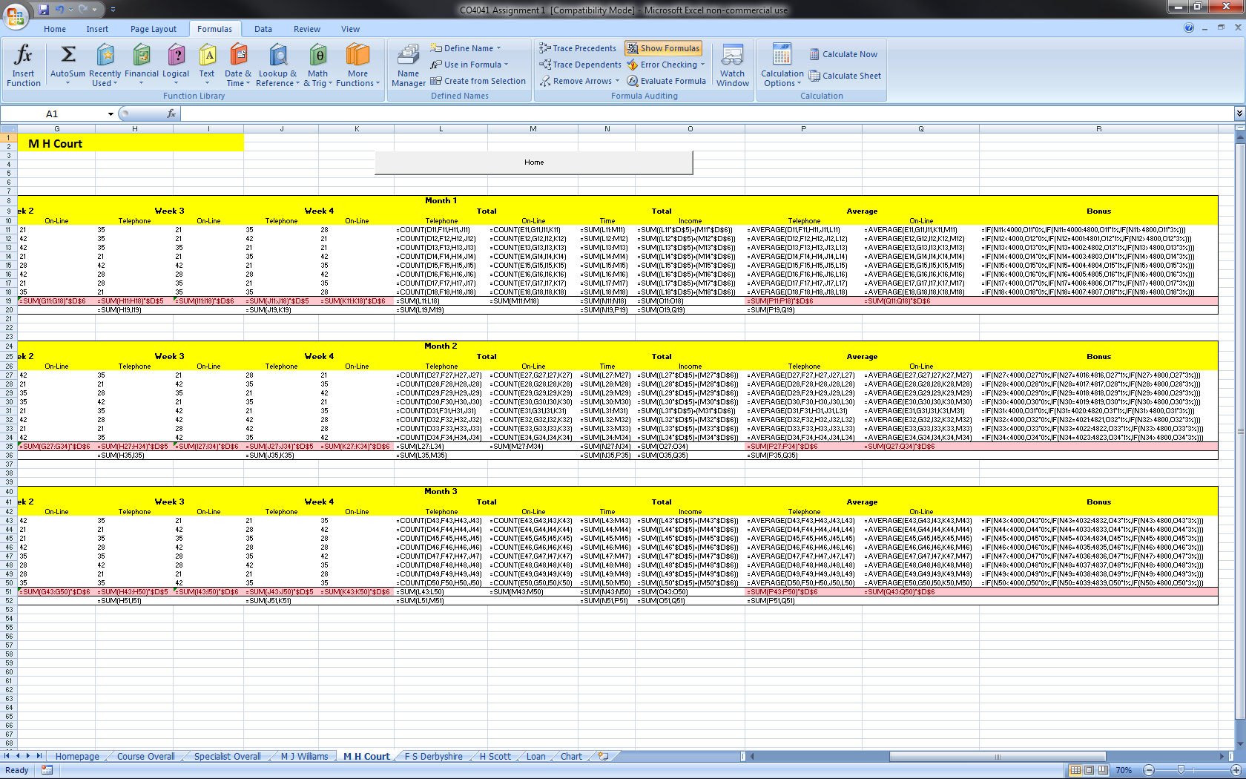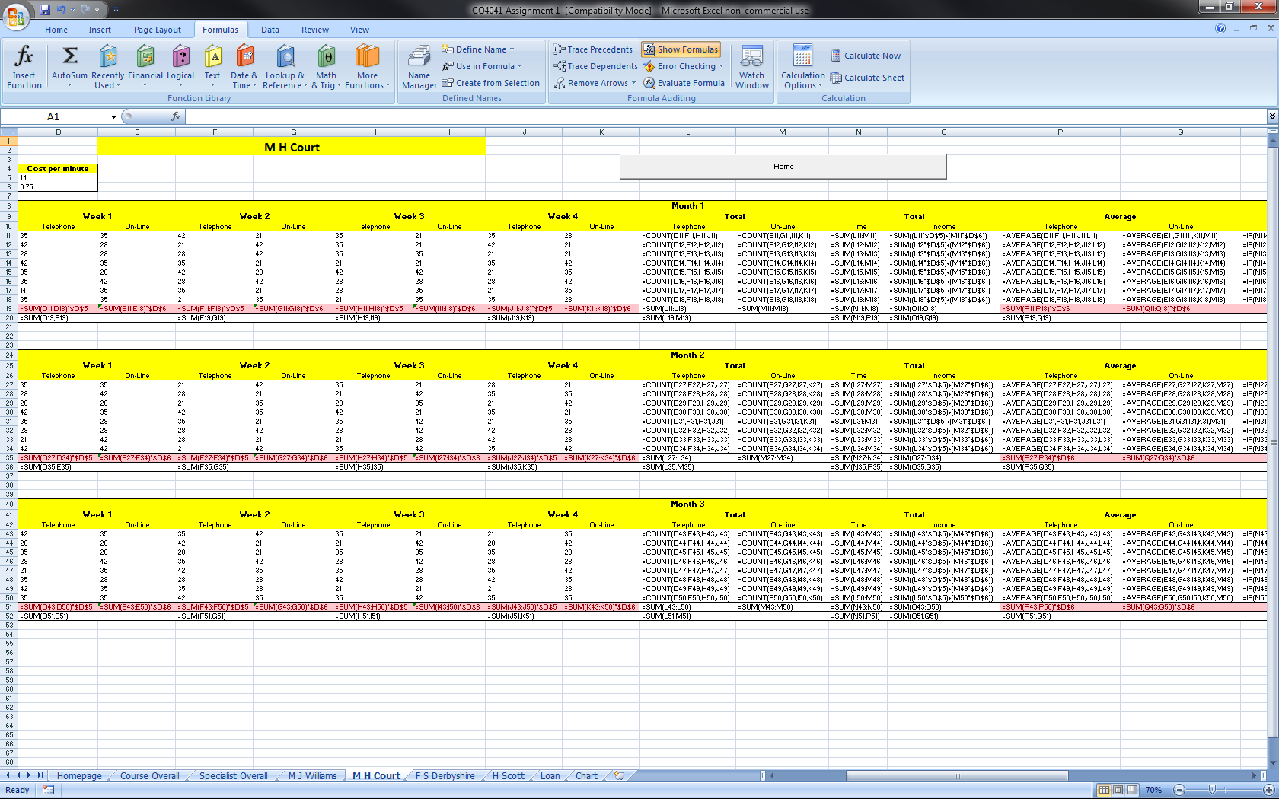

H Scott:- This is the specialist sheet 'H Scott' which displays the specific specialist information. The screenshot below shows the different features on the sheet.

The costs of the support

A macro button to take the user back to the 'Homepage' Sheet

Conditional formatting on the individual support that shows red if they are generating less than £1000

One month of the support from the course

One week of the support from the specialists

The total support of each specialist

The average support of each specialist

Overall total of the weeks support income

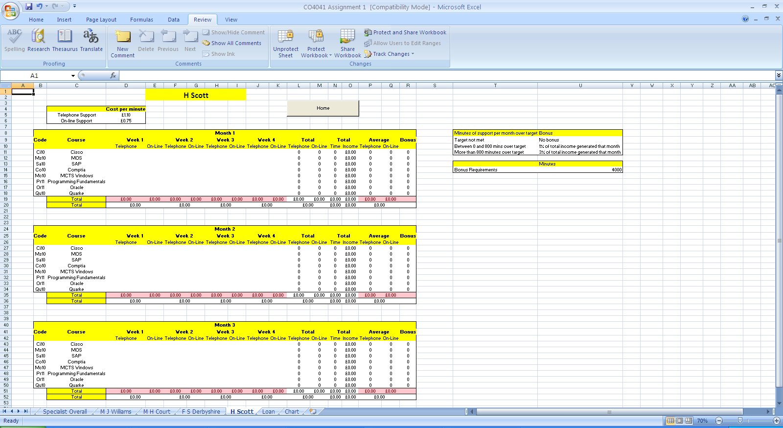

The bonus requirement for the specialist

The screenshot below shows the same sheet but will test data. The different conditionings and formulas are working correctly.

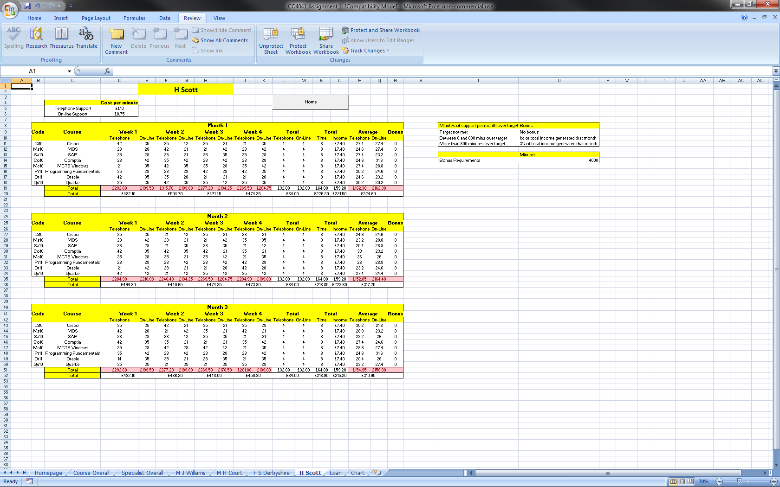

The next page shows the screenshot of the spreadsheet's formula.

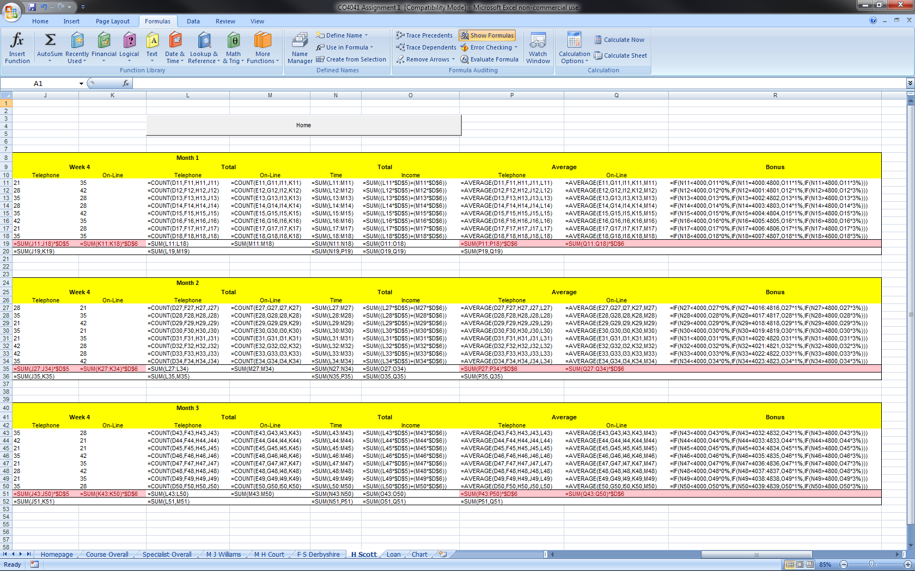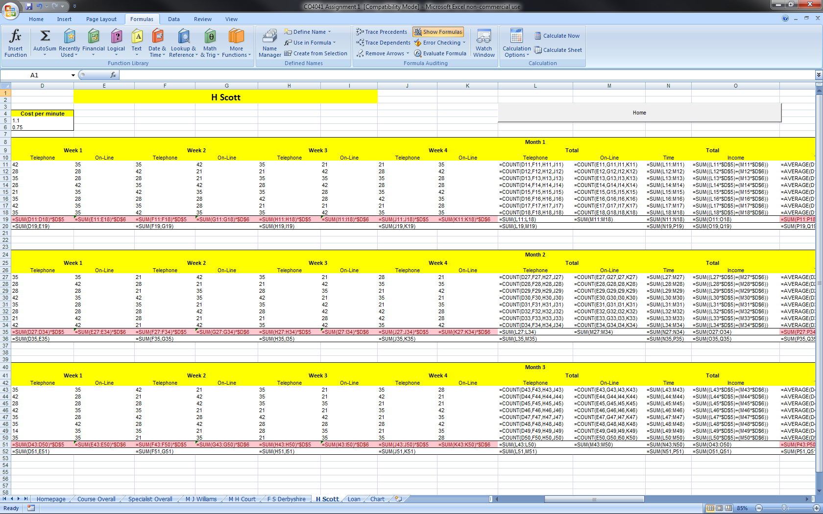

Loan:- This is the Loan sheet which displays the loan periods . The screenshot below shows all the different repayments depending of the % of interest and the time take to pay it back. It has been conditional formatted to show all the cells green if the repayment is less than £700 a month.

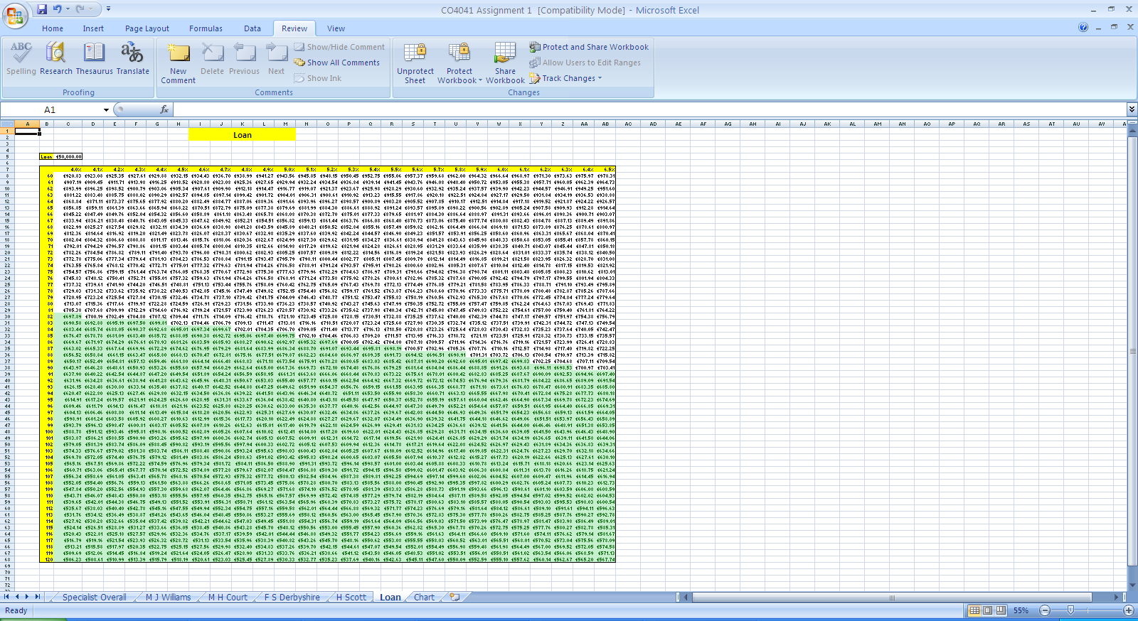

Chart:- This is the Chart sheet which displays the three months of support in a bar chart.

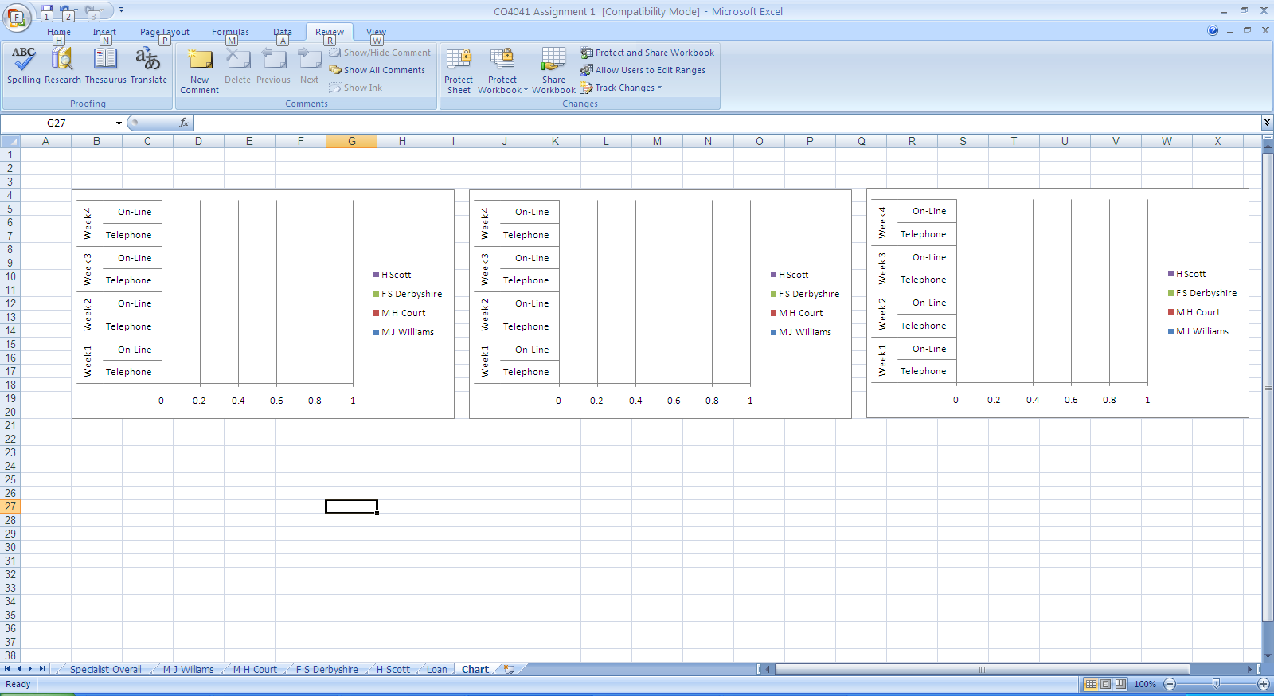

The screenshot below shows the same sheet but will test data from the other sheets. The different conditionings and formulas are working correctly.

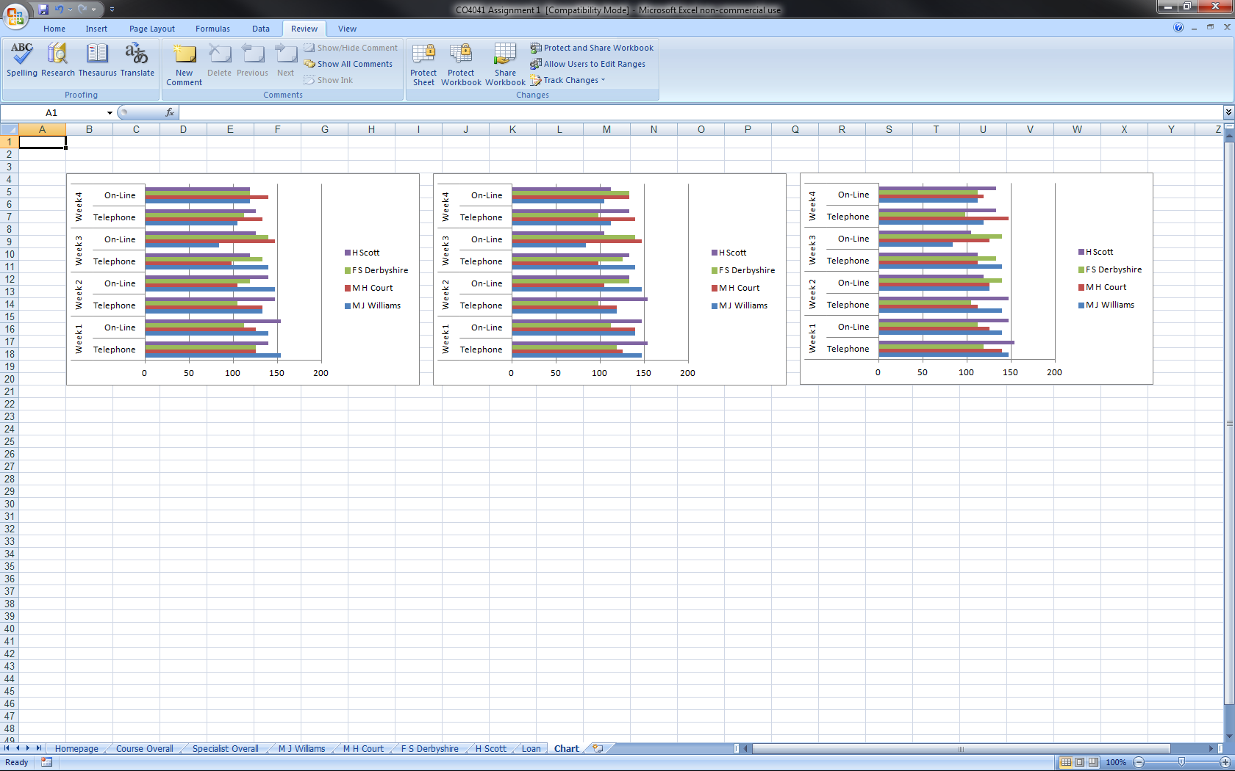

Justification of software

For Microware who wish for an electric version of their current paper base system, spreadsheets is a useful software. it is able to calculate many different sums from information gathered from the different sheets. It will also save time from the supervisor when looking at the overall information, he will be able to see which courses are doing well and which aren't, which specialist are doing well and which aren't.

Evaluation

The spreadsheet was designed and created for the purpose of handling data and information for a IT company 'Microware'. The spreadsheet consists of eight worksheets; ‘Homepage’, ‘Course Overall’, ‘Specialist Overall’, ‘M J Williams’, ‘M H Court’, ‘F S Derbyshire’, ‘H Scott’, ‘Loan’ and ‘Chart’. I have used macros on my spreadsheet to help with navigation. The first sheet ‘Homepage’ contains macro buttons to allow you easy navigation to the sheets in the spreadsheet, the sheet will all have a macro to take the user back to the 'Homepage' as well.

I have used many formulae to help calculate sums for the specialists. This helps them calculate totals, bonuses and averages much easier and faster than their paper base format previously. The formulae also make the results much more accurate than if someone had to do it themselves which would add the possibility of human error. Having the overall view of the courses will be very useful to the supervisor to decide on how the business show continue as he will be able to see which course do well and which don't.

Although the spreadsheet I created fits its purpose it is still just a prototype and there are still ways that it could be improved e.g. adding images to the homepage such as the Microware logo, or adding comment panes. I could also add some more macros such as one that would create charts monthly for the supervisor to create the m more easily if it passes the prototype stage and the n he will be able to see they are doing in chart form. A macro could also be made to print the months support time for each specialist so that they have a paper based record as a backup as well as a computer based one.